MED D - Test Claim - STCOB Accounts

Process
Related Documents

Description: This document provides instructions on how to process STCOB Accounts.

Process

Perform the steps below:

Step | Action
1 | Follow the normal Test Claim process.
2 | DO NOT quote the price on the main Test Claim screen.
3 | Click on the icon in the Details column to view the actual amount the beneficiary will pay.  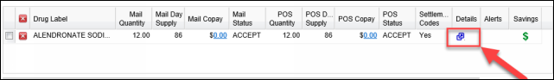
4 | View the following STCOB indicators located on the Details screen:  - Supplemental Payer/Adj. Amount indicates the amount that was adjudicated through the secondary account, not the primary.  - Settlement Code Description displays Single Transaction COB Process Used.  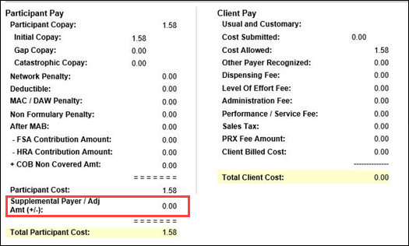  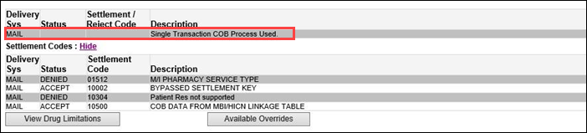

Top of the Document

Related Documents
MED D - Test Claim Index

Parent SOP: CALL-0048: Medicare Part D Customer Care Call Center Requirements-CVS Caremark Part D Services, L.L.C.
Abbreviations/Definitions: Abbreviations / Definitions

Top of the Document
Not to Be Reproduced or Disclosed to Others without Prior Written Approval
ELECTRONIC DATA = OFFICIAL VERSION – PAPER COPY – INFORMATIONAL ONLY

